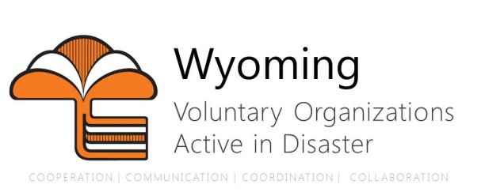

WYOMING VOAD Membership Criteria

Partner Members
Organizations, which meet all of the following criteria, are eligible for the partner category of membership in the WYOMING VOAD. The Partner membership is the voting membership.

- Organization must qualify as not-for-profit under IRS Code 501(c)(3), with voluntary memberships and constituencies.
- Organizations must have a disaster response program and policy for commitment of resources to meet the needs of people affected by disaster without discrimination.
- Organizations must be statewide in scope.

Partner Members are those organizations that can support response across the entire state without limitation. These organizations need not be an actual 501(c)3, but rather just meet the qualifications of such.

Associate Members
The Associate category of membership may be granted to organizations, government agencies, or businesses with disaster planning operations, responsibilities or capabilities that do not meet all of the criteria for Partner membership.

- Organization must have a disaster response program and policy for commitment of resources to meet the needs of people affected by disaster without discrimination.
- Organization need not be statewide in scope.

Associate members are organizations that are unique in their response capabilities. These organizations include government and other partners that don’t qualify as a voluntary organization but are vital in our partnership and coordination. These organizations also include those who may provide services to a local area, but are not necessarily structured in a way to provide those services across the state with ease.

